Kol Simcha Torah Gazette
For Vayikra 5786
Vol 10 Issue 24 (Whole #489) 3 Nissan 5786/ March 21, 2026
Printed L’illuy nishmas Nechama bas R’ Noach, a”h
For a free subscription, please forward your request to keren18@juno.com
Past emails can be found on the website ShabbosStories.com under Brooklyn Torah Gazette

The Proud Jew I
Want to Become
By Nancy K. S. Hochman

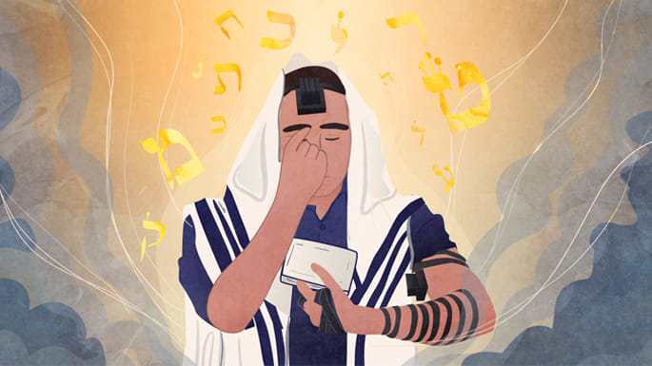
Art by Sefira Lightstone

I have a close family member—I’ll call him Jon—who is a ba’al teshuvah, a returnee to Judaism. I, too, traveled that path, but in the 20 years since Jon began his Jewish journey, he has sprinted far ahead of me, at least in terms of daily observance.
With his beard, yarmulke, and tzitzit on full display, Jon is very visibly Jewish. Since October 7th, I’ve become increasingly concerned that he might be targeted for antisemitism while traveling for work.
I’ve suggested that perhaps when arriving at the airport early in the morning, he should pray and wrap his tefillin a little further from the terminal, perhaps a bit more discreetly, or maybe later in the privacy of his hotel room. After all, with two small black boxes strapped to his arm and forehead, he looks visibly Jewish (or, to those not in the know, alien).

The Advice of Rabbi Eli Goodman
But Jon reminds me of what our Chabad rabbi, Rabbi Eli Goodman, told him about the importance of wrapping tefillin early in the morning: “You have to get hooked up from Above, in order to get hooked up from below.” Jon is getting “hooked up” by binding his mind, heart, and actions to G-d's service. That “hook up” provides distinct protective advantages in his daily life.
While I comb the papers and search the internet for the latest attacks—my own faith momentarily dwindling in the light of the news—Jon is too involved with the daily requirements of Jewish observance to focus much on the growing tides of antisemitism. Aware of my concerns, he reassures me that he will fight back if anyone tries to attack him. He is not a young man, but he's strong, and that strength is not purely physical.
Jon has not only evaded antisemitic attacks in New England, Colorado, Washington DC, and the Swiss mountains, but he has also become, in his own way, a shliach, a representative others can seek out and talk to.

Approached by Strangers in the
Supermarkets and on the Street
Many step up with a litany of questions; others talk to him about their appreciation for the Jewish people. Strangers in supermarkets and on the street, noting his yarmulke, approach him with questions and comments, some having only ever met a handful of Jews.
And so far, these strangers have proven warm, friendly and accepting. One Chinese gentleman approached him, wanting to know more about Kabbalah and whether it’s similar to the concepts of Yin and Yang in Buddhism. A non-Jewish woman in a health food store showed him a package and asked if the kosher certification was considered reliable enough for her kosher-keeping friend.
Jon shares whatever information he has, but often ends up simply nodding his head in encouragement while people speak of their own faith or reminisce about their Jewish encounters. These little ”meetings” take anywhere from five minutes to half an hour.
One especially memorable moment occurred while visiting a client in Virginia, who did everything but hug him when he entered her office wearing his black knit yarmulke. She told him that her mom used to work for a Jewish family, and that she had been raised in that same Jewish house. She began to reminisce about Shabbat and Passover dinners, about chicken soup and kugel, and all the holidays she helped prepare for and often took part in. She loved both the warmth and traditions of the Jewish people and Jewish culture.

Reactions from Those Not Visibly Jewish
Sometimes I travel with Jon. On one of our trips, to visit family out West, a young man who wasn’t visibly Jewish wished us “Yom tov” (“Have a good day”). This acknowledgment from a member of the clan whom I have not yet met reminds me of the innate and unbreakable bond that all Jews share.
While we are increasingly targeted as “other,” our ties to our fellow Jews grow stronger. Since October 7th, others have yelled across store aisles and from down the street, “Am Yisrael chai!” We’re never sure whether they’re Jewish or not, but it doesn’t much matter. It’s good to have allies.
On one trip to Colorado, we were in a neighborhood supermarket, where two employees stood by the self- checkout, both with distinctly Muslim-sounding names on their badges. I looked at both young men, trying to read their expressions, but their eyes were carefully focused on Jon, who was checking out.

Being Greeted with “Salam Alaykum”
Then one spoke. “Salam alaykum,” he said, using the Arabic greeting that mirrors the Jewish “Shalom aleichim,” “Peace be upon you.” Jon responded in kind, in Hebrew: “Aleichem Shalom.” Especially after seeing the lies, animosity, and misunderstanding so many have swallowed whole over the past few years, I find hope and renewal in the shared greeting between cousins of goodwill.
Ultimately, G-d gives us all different capabilities, and it is our responsibility to hone and maximize those abilities to become His messengers. While I attempt to counter hatred and ignorance with research and words, sometimes finding myself belly down in the muck, I see the value and power in Jon’s way: making a profound impact simply by going through life as an open and visibly identifiable Jew.

Reprinted from the current website of Chabad.Org

The Significance of the “Wood Donations to the Holy Temple
From the Teachings of the Lubavitcher Rebbe
Rabbi Menachem Mendel Schneerson, Zt”l
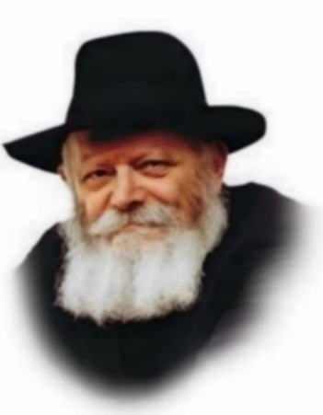
This week's Torah portion, Vayikra, is the first portion in the book of Leviticus. It discusses the various types of sacrifices the Jewish people were commanded to offer during the times of the Tabernacle and later the Holy Temple. In the description of the first few types of sacrifices, the wood used for the fire on the altar is mentioned numerous times.

Several Families Banded Together tp
Donate the Wood for the Second Temple
The Talmud relates that when the Jews returned to Israel from the Babylonian Exile, after the destruction of the First Holy Temple, they found no wood for the altar in the Temple's storehouses. Several families banded together and donated wood. Later, these families were given the permanent honor of supplying the wood for the altar. The Sages decreed that the days when the wood was donated should be celebrated as a minor festival by the families.
Interestingly, there is another instance in which celebrations are connected to wood. The Mishna states: "There were no other holidays as great to all of Israel as the 15th of Av and Yom Kippur." One of the reasons for the joy on the 15th of Av was that this day marked the end of the harvest of trees whose wood would be used to burn the sacrifices.

The Significance of the
Wood for the Temple
What is so significant about the wood for the altar that its donation mandated an actual holiday, and its harvest brought such joy to the entire Jewish nation?
The wood was not merely fuel for the fire by which the offerings were burnt; it played a far deeper role in the spiritual function of the Holy Temple, and was an essential element of the sacrifices themselves.
But to grasp the importance of wood, we must first understand the significance of the sacrifices. According to Nachmanides, an individual bringing an offering was to have in mind that the animal being slaughtered was in his stead. Only through G-d's good will did He accept an animal in exchange.

The Proper Reflections and
Meditations for Each Offering
There were many different types of offerings, and the thoughts accompanying each of them varied. For example, when a person brought a sin offering, he was required to dwell on thoughts of repentance and make amends for his wrongdoing, whereas the thanks-offerings aroused a deep love for G-d. Each offering was to be brought with its appropriate reflections and meditations.
But the most fundamental thought of all, no matter which offering was brought, was that of giving oneself totally over to G-d. This absolute self-sacrifice transcended any personal emotions or motivations. Only after this requirement was met could the individual go on to express the emotions demanded by the particular offering.
This self-sacrifice was expressed by the burning of the wood on the altar. The Torah likens man to a tree. The burning of the wood symbolized the willingness to sacrifice oneself without personal considerations. For, when bringing an offering, the donor might derive some degree of satisfaction, personal glory or benefit from the act. However, the burning wood reminded him that there should be no such ulterior motives. The celebrations surrounding the provision of wood for the altar therefore epitomized the purest and most lofty aim of the sacrifices themselves.
Adapted from the works of the Lubavitcher Rebbe

Reprinted from the Parashat of Vayakhel 5763/2003 edition of L’Chaim, a publication of the Lubavitch Youth Organization. Adapted from the teachings of the Lubavitcher Rebbe, zt”l.

Rav Avigdor Miller on
Covering Hair After Marriage

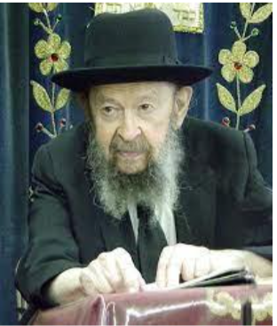

QUESTION: Why must a married woman cover her head? Why is it so important?
ANSWER: A married woman now has to know that she is for one man. That’s the only one who has to know she’s a woman. And therefore, the Ramban says on a sotah, when the sotah, a woman who was disloyal to her husband and she has to drink the mayim hamarim, so they undo her hair. And he said, because when hair is made up, hair is tidied up and made neat and beautiful, it’s because the wearer of the hair is a candidate for some experiences. Wearing fancy hair means you’re a candidate for certain activities.
So therefore, only your husband should know about your candidacy. And all others should see a substitute for hair. So, a married woman has to make it her business to be beautiful and attractive just for one man in the world. That’s her function.
Of course, she has a lot of things to do in this world. She doesn’t have to be only beautiful for her husband. She has to be beautiful to Hakodosh Boruch Hu too. Of course that’s the main achievement of a person. But still physical beauty is to be displayed only to a husband. And that’s why her hair has to be covered up.
Now girls are permitted to uncover their hair because girls have to advertise that they are available. They don’t have one man yet. But as soon as the one man comes and says, “הרי את מקודשת,” and there’s a chuppah, so she covers up because it’s all over. Romance as far as other people are concerned is all over.
And any woman who is interested in displaying her charms to others, is still hoping for some more romances. And to us, that’s treif like chazir. It’s tamei. טומאה כתיב בה כעריות. To us, it’s filthy. If a married woman is interested in being attractive to men, to us it’s plain dirty.
And that’s why we can consider it important for a married woman to cover up. Of course she can be respectable, she can be well dressed, all that is alright. But she shouldn’t make it her business to be attractive to others.
(Jan 1979)

Reprinted from the archives of Toras Avigdor. Transcribed from a classic Thursday night lecture delivered in January 1979).

Thoughts that Count
For Our Parsha

A person who brings close [offers] from you a sacrifice to G-d. (Lev. 1:2)
Grammatically, "A person from among you who brings close a sacrifice," would have been more correct. But, the Torah teaches us a lesson from the order of the words. If you wish to be close, it comes "from you" - it is only dependent on you. Any Jew who wishes, can reach the lofty heights of closeness to G-d attained by our great forebears. (Rabbi Yosef Yitzchak of Lubavitch, the Previous Rebbe)

Writes Rabbi Shenur Zalman, founder of Chabad Chasidism: "A person who brings close" - in order that a person becomes closer to G-d - "from you a sacrifice to G-d" - he must bring the offering of himself. He must sacrifice his personal "animal," the desire for evil that is called the animal soul. (Hayom Yom)

Do not leave out the salt. (Lev. 2:13)
The salt was an integral part of the sacrifices. Though not edible on its own, salt adds flavor to the entire meal. The same is true regarding Torah. Chasidism, the inner secrets of Torah, though not widely understood because of its profundity, provides the flavor and background for the remainder of the Torah. (Rabbi Shneur Zalman)

You may not burn any leaven or any honey as a fire offering to G-d. (Lev. 2:11)
"Any leaven" is a person who is moody or melancholy. In the morning or evening, on Shabbat, holidays or weekdays, he is always sour. "Any honey" is one who is always pleasant and sweet. Whatever happens, he's always smiling. "You may not burn [either of them] as a fire offering to G-d!" You cannot properly bring a sacrifice to G-d from either of these emotions. A person must rule his character traits, even his positive attributes. For surely there are times when one must be "leaven" and times when one must be "honey." (Rabbi Shmuel of Lubavitch)

Reprinted from the Parashat of Vayakhel 5763/2003 edition of L’Chaim

The Synagogue Was Attacked and Our Children Were Watching
By Tsachi Shemesh



When 140 Jewish children were evacuated from a burning synagogue in Michigan, every parent faced the same question: now what do we say?
On a Thursday morning in West Bloomfield, Michigan, 140 children were sitting in their classrooms at Temple Israel when a man rammed a truck loaded with fireworks into the building. Security guards exchanged gunfire with the attacker, the truck caught fire and attacker took his own life.
The children and teachers were evacuated. It was a normal day at their Jewish day school until it wasn't.
Children don't wait for a formal conversation to understand the world. They watch. They listen for the hesitation in a parent's voice when something comes on the news. They notice when the kitchen conversation suddenly changes direction. And when 140 kids are rushed out of a synagogue by their teachers, something registers — in them, and in every Jewish child who hears about it afterward.
An adult processes the security failures, the attacker's biography, the political context. A child processes something more direct: people who look like me, in a place like mine, had to run.
What happens next — the conversations, the silences, the explanations adults choose to give or avoid — becomes the actual lesson.
Silence is never neutral. It's part of the curriculum.

The New Normal
What's changed isn't that antisemitism exists. It's that it's no longer hiding. Across North America and Europe, Jewish families are navigating harassment in schools, graffiti in public spaces, and demonstrations where antisemitic chants ring out openly in the streets. And more violent attacks on Jewish institutions. The hostility that once operated behind closed doors has moved into plain sight.
Harassment in schools, graffiti on walls, antisemitic chants in the streets, and now a truck driven into a synagogue full of children. The hatred is out in the open.
This changes things inside Jewish homes. Parents now face a question that used to feel theoretical: how much do we explain, how much do we shield, and what does protection actually mean?

Two Ways to Respond — and What Each Teaches
Some parents respond with caution. Keep a lower profile. Think carefully before speaking about being Jewish in public. These instincts come from genuine concern for safety, and no one can fault a parent for wanting to reduce risk.
But children hear the emotional message underneath the words. When caution becomes the dominant tone, identity starts to feel like something to manage rather than something to own. A child learns that expressing who he is requires calculation.
Other families take a different approach. They talk openly about Jewish history — not to frighten, but to provide context. They explain that Jewish life has always included moments when dignity required clarity rather than retreat. They teach that belonging to the Jewish people means standing inside a story far older and more enduring than whatever hostility exists in the present moment.
That child walks into a classroom differently.
Neither approach makes the world safer. Both are attempts to prepare the next generation. The difference is what a child believes about himself when he gets there.

What Institutions Owe Our Children
Schools, universities, and civic organizations shape the moral climate children grow up in. When antisemitic incidents occur, how leadership responds communicates values far beyond the immediate event.
The real test is consistency. When institutions respond swiftly to discrimination against some groups and cautiously to hostility toward Jews, children notice. Young people are careful observers of fairness. When the standard shifts depending on who the target is, the message lands clearly — and it isn't a good one.
Jewish communities deserve the same moral clarity extended to everyone else.

What Jewish History Actually Teaches Us
Jewish parents in cities across North America have found themselves having harder conversations more often since October 7. Children ask direct questions: Why do people hate Jews? Why does this keep happening? What should I do if it happens to me?
The answers that work aren't the ones that minimize. They're the ones that give children a framework larger than their own fear.
The answers that work aren't the ones that minimize. They're the ones that give children a framework larger than their own fear.
Jewish history is that framework. Teach your children that hostility toward Jews didn't begin in their lifetime — and that Jewish life didn't disappear because of it. Across centuries and continents, Jewish families preserved their identity not by hiding it but by transmitting it: stories, values, and responsibilities passed from one generation to the next even when public expression carried real risk.
That transmission is still the job. And it's more urgent now than it was five years ago.
The Goal Is Character, Not Fear
A child who understands his identity and his responsibilities carries himself differently through the world. He recognizes hostility when it appears. He also knows that his identity isn't defined by the hostility of others.
That's the goal — not a child who is fearless, but a child who is grounded. One who has been taught that being Jewish is something to stand inside, not something to manage around.
Those 140 children evacuated from Temple Israel will remember that day for the rest of their lives. What they carry forward — fear or groundedness, shame or pride, silence or clarity — depends largely on what the adults around them do next.
Your children are watching how you respond. Make it count.
Reprinted from the current website of aish.com
Rav Reuven Feinsten
Photo By Marko Dashev
B
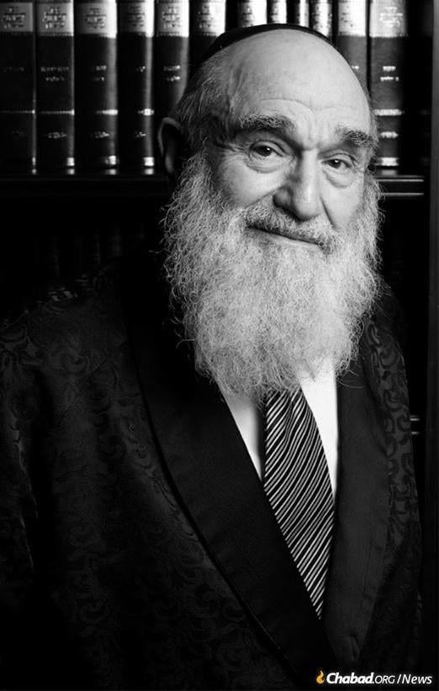
The Power of Words:
A Whisper That Nearly Destroyed a Wedding
By Naama Green

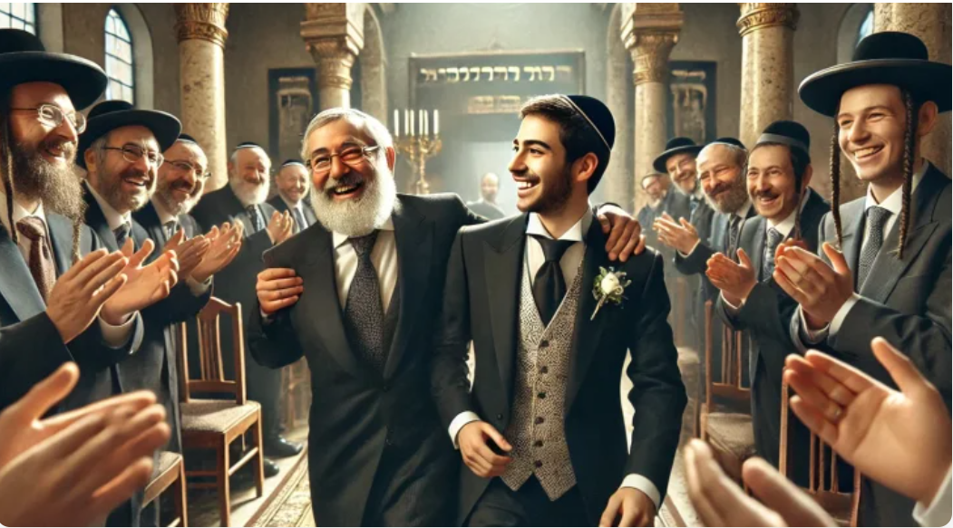

A jealous whisper nearly destroyed a young couple’s future until Rav Shach took extraordinary steps to restore the truth.

It was Shabbat, and the brilliant Torah scholar Rabbi Ben Tzion Felman, then a young avreich, was staying at his parents’ home in Tel Aviv.
That Shabbat, one of the congregants of the Heichal Meir synagogue had just celebrated his daughter’s engagement to a yeshiva student. As was customary, the groom came to spend the Shabbat after the engagement with his future in laws and share the Shabbat meals with them.
The bride’s father entered the synagogue together with his new son-in-law, glowing with happiness over the “diamond” that had come into his family. The congregation shared in his joy and gathered around to offer warm wishes of mazal tov.
A Poisonous Whisper
Among those congratulating him stood a man whose heart was filled with jealousy. In the middle of the celebration, he leaned toward the bride’s father and whispered quietly:
“I think you made a mistake. This young man barely prays. I once checked into him and heard that he wastes most of his day doing nothing. It was foolish to take him as a son-in-law, but what’s done is done.”
The father-in-law was stunned. The words seeped into his heart like venom. By Shabbat afternoon he was already confiding to another congregant, “It seems I’ve fallen into a trap…”
The groom himself soon sensed that something had changed. The warmth he had felt from his future father-in-law had suddenly cooled. He could not understand what had happened, but a quiet fear began to grow inside him. The rest of the Shabbat passed under a cloud of tension and disappointment.

Witnessing a Terrible Moment
Rabbi Ben Tzion Felman had been standing nearby on Friday night when the slanderous whisper was spoken. The moment shook him deeply.
To him, it felt like witnessing someone stab another Jew in the heart with a few carefully chosen words. Several souls had been wounded in an instant.
He could barely bring himself to eat the Friday night meal. His stomach churned. He knew the groom personally and was certain the accusations were completely baseless.
Yet Rabbi Ben Tzion was known for his careful speech. He did not rush to intervene impulsively.
“Better a few words, sharp and precise like arrows, than many careless ones,” he would often say. “Sometimes words can cause more harm than help.”
Throughout the entire Shabbat he remained deeply troubled. Several times he felt tears welling in his eyes. It felt as though he had witnessed a terrible crime.
“What should I do?” he wondered again and again.
Who would believe the testimony of a young avreich over the confident claim of an older and respected man?

A Sleepless Night
After Shabbat, Rabbi Ben Tzion returned to his home in Bnei Brak, but he could not sleep. The incident kept replaying in his mind.
Early Sunday morning he set out as usual for the Ponevezh kollel. Along the way he met Rabbi David Frankel, a distinguished student of the Chazon Ish and the Brisker Rav.
Rabbi Frankel immediately noticed the distress on his friend’s face.
“What happened? Why do you look so troubled?” he asked.
Rabbi Ben Tzion told him the entire story.
Without hesitation, Rabbi Frankel advised him, “Go immediately to Rav Shach and ask what should be done.”

Rav Shach’s Immediate Decision
Instead of continuing to the kollel, Rabbi Ben Tzion turned toward Rav Shach’s home and recounted the painful episode in detail.
Rav Shach listened carefully and then asked, “And how do you think I can help in this matter?”
Rabbi Ben Tzion suggested, “If we could find their address in Tel Aviv, perhaps the rosh yeshiva could come with me to visit them and speak to them.”
Rav Shach considered the idea but raised a concern.
“I do not know this young man personally. He is not one of my students. How can I praise him if I cannot testify to what I know to be true?”
Rabbi Ben Tzion replied, “I know him very well. I can testify with certainty that the accusations are completely false. He is an outstanding young man, filled with Torah and yirat Shamayim.”
Rav Shach immediately stood up.
“If that is the case,” he said, “I will put on my hat and jacket, and we will go now to Tel Aviv.”

The Journey to Restore a Life
Rabbi Ben Tzion suggested ordering a taxi, but Rav Shach refused.
“We will take the bus,” he said.
They boarded the bus together. When Rabbi Ben Tzion tried to pay the fare, Rav Shach stopped him.
“I will pay for both of us,” he insisted.
During the journey Rav Shach continued asking questions about the young man’s character, listening carefully to every detail.
When they arrived in Tel Aviv, the two men walked toward the address of the bride’s parents. Rabbi Ben Tzion remained outside while Rav Shach went upstairs.

A Few Words That Changed Everything
Rav Shach knocked on the door. The parents opened it and were astonished to see the head of the Ponevezh yeshiva standing before them.
Without lengthy introductions he said warmly:
“I happened to be in the area and heard that your daughter became engaged to this young man. I told myself I could not pass by without wishing you mazal tov and telling you about the great fortune that has come to your family.
“This young man is like family to me. He is an exceptional individual, filled with Torah and fear of Heaven. He studies diligently and has a very promising future. Not everyone merits such a diamond.”
Rav Shach continued speaking until he saw the parents’ faces soften and their joy begin to return. Only then did he take his leave with blessings and warm wishes.
Later, when Rav Shach received the wedding invitation, he showed it to Rabbi Ben Tzion with quiet satisfaction.
Rabbi Ben Tzion would end the story with a humble reflection:
“Today that young man is already a grandfather. He has no idea what Rav Shach once did for him.”
In his modesty, Rabbi Ben Tzion never mentioned that he too had played a crucial role in that great act of kindness.
Rabbi Shalom Ben Tzion Felman (5694–5775) later became a renowned posek of halacha, the rabbi of the Nachalat Moshe community in Bnei Brak, and the author of the halachic series Shalmei Todah.

Reprinted from the current website of Hidabroot - from the book Without a Name.

Rabbi Shalom Arush
Photo by Marko Dashev
